**Documentation for the explanation of that menu driven**

**selection feature**

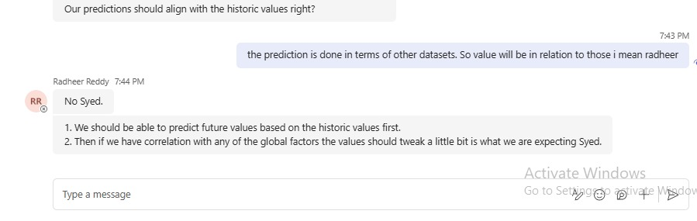

Image 1

According to this image1, the neural network has to be designed to predict values primarily based on historical data. If there’s a correlation with other factors (like GDP, GNI, etc.), the predictions are slightly adjusted to account for those too. **Our code meets these expectations**. The neural network’s input layers include both the historical data and these additional factors, ensuring the model learns from all the important factors, not just the historical values.

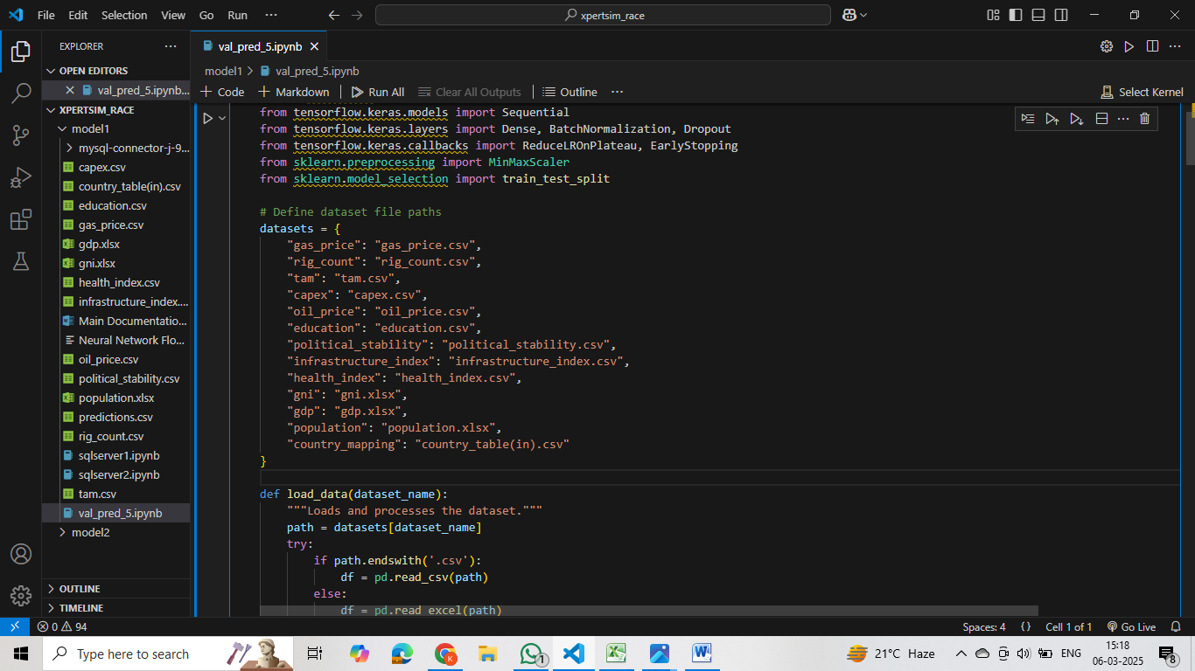

Image2

We are feeding NN with all datasets to train so values are dependent on those datasets (image2). The impact of each dataset is determined internally by the neural network. This analysis happens implicitly within the model and is not explicitly shown.

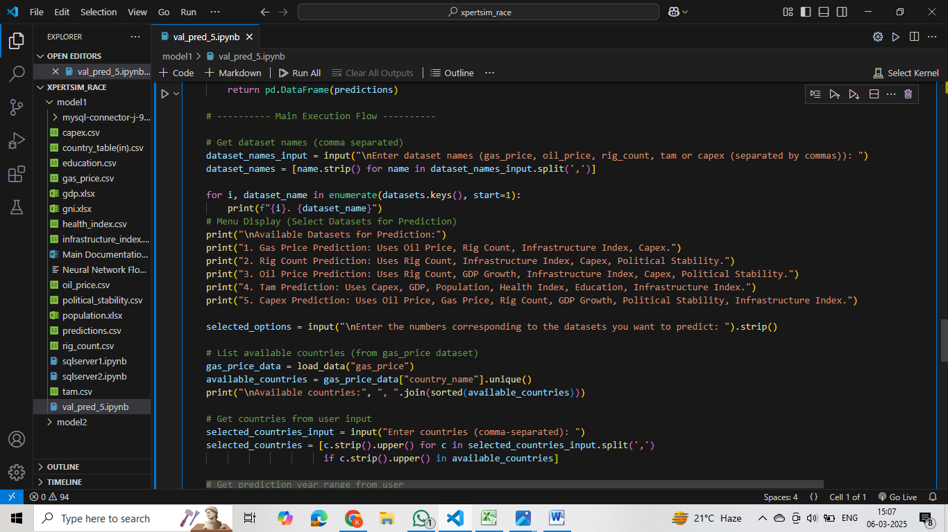

Image 3

We’ve also included the option to let user select input variables (in image3) as a future feature. This will allow users to pick specific factors and see how they affect the results. Right now, this feature doesn’t impact the training process, so it’s not included in the training-related code. However, we’ve kept it in the code to make the system more flexible and easier to update in the future.